**Bird Feeder for Poultry Conditioning**

**Objective:**

The growing demand for poultry products by consumers has called for the need for small and medium poultry farmers to meet the demand as they provide greater market demand especially in developing countries. There is a need to produce birds that will meet market standards in the short term without compromising the farmer’s time, resources and energy. In this project work an effort has been made to improve the work / save time that automatically feeds the feed which will increase bird feed. There are many automatic machines for feeding birds and large chickens. But it is difficult or impossible to install large machines with small chickens in the middle. Small and medium-sized chickens are usually handled by local farmers. For small and medium-sized chickens they are fed with a feeder that needs to be replenished. This costs more labor costs and more time for farmers. With a view to making a simple and effective feed of medium and medium-sized chicken feed, it was suggested that the design and design of an automated chicken manufacturer be developed.

**Hardware & Software Requirements:**

1. Arduino Mega 2560
2. PSD tuned PID controller
3. DC Motor
4. Feed Level Sensor
5. Push Button
6. DC Liquid Pump

**Project Flow**

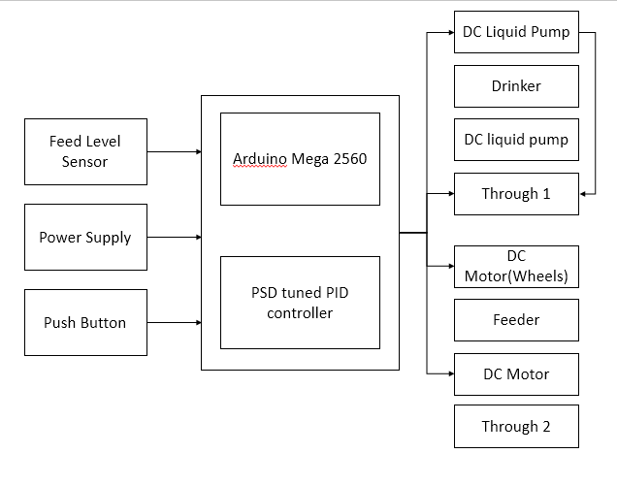

**Proposed System:**

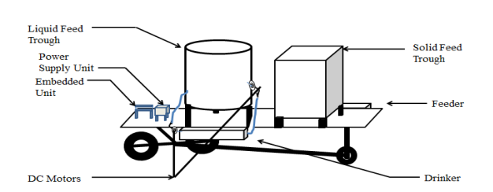

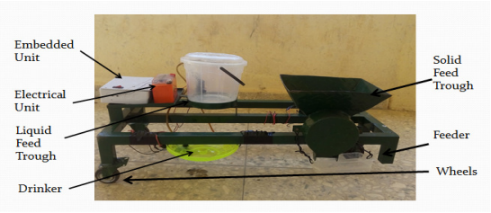

**Stake Holders:**

The main consumer would be those who own the farm field. Since the farm field requires a lot of machinery works, this would be a perfect tool to those farm field owners. Then comes the industrialist who design this tool in such a way that It would be affordable and can be easily used by the consumers. Since this can be achieved under a minimum budget and this would be a great value in the market, additional features can also be added in order to gain more consumers. Finally comes the researchers who combines with all department to make it even further easier and safer for the users, and of course the birds eating them.